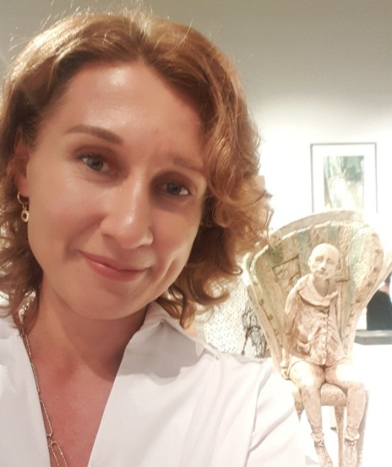
​ Asya Dudko BA (Hons), SWA
Figurative Sculptor & Visual Artist
Milton Keynes, United Kingdom
📧 asyadudkoartist@gmail.com
🌐 www.asyadudkoart.com
📷 Instagram: @asyadudkoart
📘 Facebook: facebook.com/asya.dudko

Profile
Asya Dudko is a figurative sculptor and visual artist whose practice merges sculpture, painting, and relief art. Born in Russia, she grew up immersed in folklore, craftsmanship, and the emotional richness of her cultural heritage: enduring influences reflected in her use of symbolism, texture, colour, and poetic narrative.
Her work explores themes of memory, resilience, mystery, and human connection through stylised figurative sculptures rich in symbolism and quiet narrative. Drawing on personal experience, inner reflection, and a lifelong journey of self-discovery, she creates contemplative works that invite viewers into a world of imagination, emotion, and meaning. Drawing inspiration from Russian legends and fairy tales, Asya incorporates recurring motifs such as birds, fish with human faces, keys, bells, and winged figures, creating works that invite contemplation and emotional reflection.
Asya has developed a distinctive sculpting technique using Creative Paperclay, building expressive textured surfaces over wire armatures and finishing each piece with layers of acrylic and oil paint. Vintage and found objects are often incorporated to deepen the conceptual narrative.
After relocating to the United Kingdom in the early 2000s, Asya earned a First-Class Honours Degree in Interior Design and now teaches sculpture and relief workshops from her studio at Westbury Arts Centre, Milton Keynes.
A Full Member of the Society of Women Artists (SWA), Asya regularly exhibits at the Mall Galleries, London. Her work is held in private collections in the UK, Russia, and Switzerland.

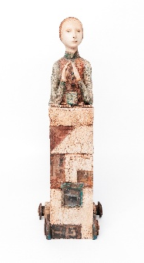 | The One Who Holds the Roof  Paperclay  39x13x13cm  2026 | 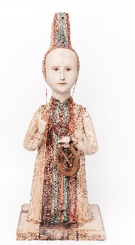 | The Guardian  Paperclay  51x20x21cm  2025 | 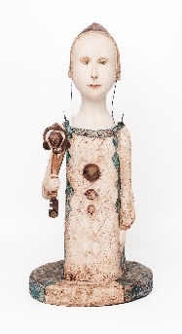 | Keeper of My Own Key  Paperclay  47x23x21cm  2025 | 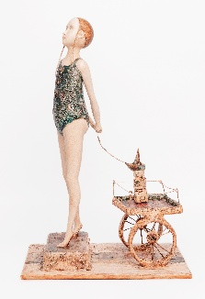 | Long Walk to Where the Road Meets the Sea  Paperclay  44x30x20cm  2025

Education
BA (Hons) Interior Design
First-Class Honours Degree, United Kingdom

Professional Memberships
2026 – Present
Full Member, Society of Women Artists (SWA)
2025 – Present
Member, Visual Artists Association (VAA)
2022 – 2025
Associate Member, Society of Women Artists (ASWA)

Awards & Recognition
2026 —Beautiful Bizarre Art Prize 2026 Showcase, International Online Feature
2026 —Full Member, Society of Women Artists (SWA)
2025 — VAA Art100 International Award Winner
2025 — John Doubleday Award, Galeria Moderna, London
2025 — Galeria Moderna Award, London Invitational Contest
2025 — Featured Artist Interview, Cass Art
2025 — Longlisted Artist, VAA Artist of the Year Awards
2022 — Helen Sinclair Sculpture Award, Society of Women Artists

Selected Exhibitions
2026
- Green & Stone Summer Exhibition 2026, London
- A New Legacy: Society of Women Artists, Stephenson’s Gallery, York
- 77th Annual Chelsea Art Society exhibition, Chelsea Town Hall, London
- Society of Women Artists 165th Annual Exhibition, Mall Galleries, London
2025
- Society of Women Artists 164th Annual Exhibition, Mall Galleries, London
- Galeria Moderna Exhibition, The Sidings, London
2024
- Royal Society of British Artists Annual Exhibition, Mall Galleries, London
- Society of Women Artists 163rd Exhibition, Mall Galleries, London
2023
- Women in Art Fair, Mall Galleries, London
- Open Art Exhibition, Discover Bucks Museum, Aylesbury
2022
- Society of Women Artists 161st Exhibition, Mall Galleries, London
- Bledlow Art Exhibition, Buckinghamshire
- Art for Interiors, Henley-on-Thames
Earlier Exhibitions
- Off the Wall Exhibition, Discover Bucks Museum (2021)
- Longwick Art Show, Princes Risborough (2022–2026)
- Bucks Art Weeks, Buckinghamshire (2018–2026)
- Obsidian Art Gallery, Stoke Mandeville (2021)
- Elena Gromova Gallery, Moscow, Russia (2014)

Residencies
2013 — Artist in Residence, Egham, UK
2012 — Artist in Residence, Old Windsor, UK

Teaching
Tutor and workshop leader specialising in:
- Figurative sculpture
- Creative Paperclay techniques
Studio Holder & Tutor
Westbury Arts Centre
Milton Keynes, UK

